Improvement of Conv | DFRC robust convolution kernel for dynamic fuzzy scenes based on YOLOv11
Present：
The improved mechanism based on YOLOv11 in this paper is an innovative network improvement mechanism designed for motion blur scenarios often caused by wind and equipment vibration. We introduce the Dynamic Fuzzy Robust Convolution (DFRC) module, a plugin-switch enhancement of the detection framework, which adaptively fuses multi-scale features and synthesized fuzzy cues through a transparent perception mechanism. Considering the deployment of edge devices, parallel computational algorithms are designed for the nonlinear difference and feature tensor rotation part in conjunction with CUDA.This work provides a practical and effective solution for fuzzy robust agricultural monitoring, shifting the paradigm from fuzzy removal to fuzzy sensory perception.
Dynamic Fuzzy Robust Convolution Introduction to the Mechanism Principle
Dynamic Fuzzy Robust Convolution (DFRC) is an advanced convolution mechanism, termed as enhanced feature extraction in object detection and segmentation tasks, the following main principles and mechanisms of DFRC:
1. Application of different receptive fields: The core idea of DFRC is to select medium and large receptive fields in the FPN backbone network, to feel the motion blur features in general, and on the other hand, to avoid reading small receptive field features to bring blur feature interference.
2. Fusion Transparency Convolution Switch: Another key point of DFRC is to use 1*1 switch convolution to combine fuzzy features and regular features, the switch convolution is spatially dependent, which means that each position of the feature map is likely to be dynamically output with the selection of the switch, so that the recognition network can be flexibly selected according to the scene.
3. Switching mechanism: DFRC is able to build a fuzzy convolutional recognition network based on YOLOv11's FPN backbone network, which effectively integrates YOLOv11's FPN with different output units, making the fuzzy recognition network construction more flexible.
4. Structural design: The architecture of DFRC consists of three main parts: two global context modules are located before and after the DFRC component, which help to understand the image content more comprehensively, and enable the DFRC component to work effectively in a wider context.
Summary: With these designs and mechanisms, DFRC improves the adaptive performance of YOLOv11's FPN network in dealing with features of different scales and complexity, thus showing significant performance gains in the field of object detection and segregation.
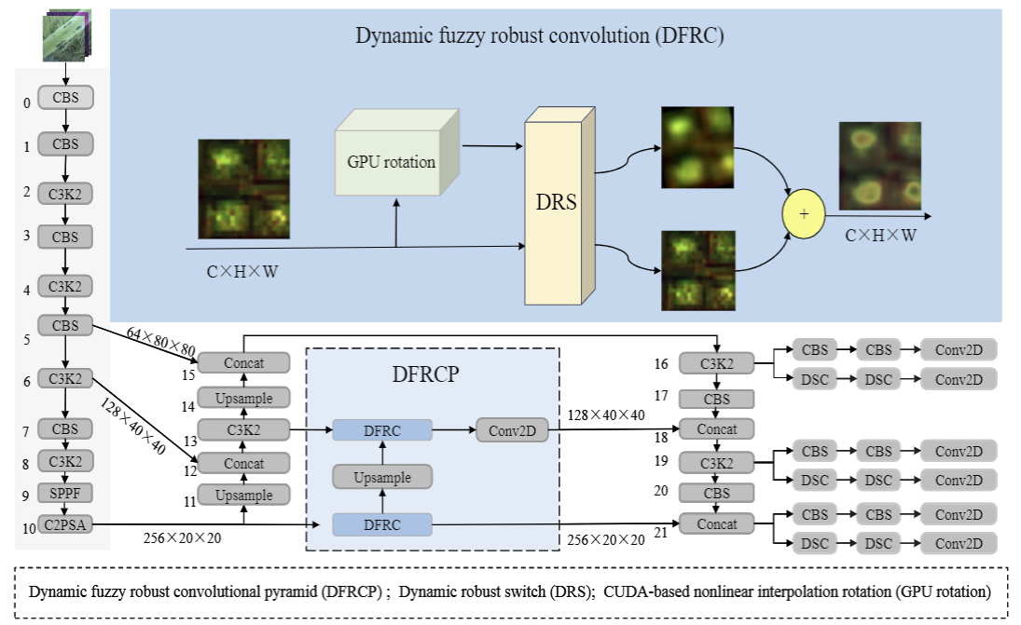
The above figure shows the FPN part of DFRC embedded in YOLOv11. The DFCP network architecture realizes accurate detection through multi-module synergy and hierarchical feature processing: feature extraction unit is constructed based on the CBS module, the C3K2 and SPPF modules enhance the ability to capture deep semantic information, and the C2PSA module improves the feature discrimination ability under the self-attention mechanism. At the same time, up-sampling and jump connection are used to achieve cross-scale feature alignment, and the DFRC module further optimizes the channel fusion efficiency. Finally, the target localization and classification is completed by the multi-branch output layer composed of CBS, DSC and Conv2d. The overall design strikes a balance between feature extraction depth and multi-scale fusion accuracy, and the new DFCP branch does not affect the native YOLOv11 features, which enhances the robust detection performance in dynamic fuzzy environments and provides strong architectural support for the model.
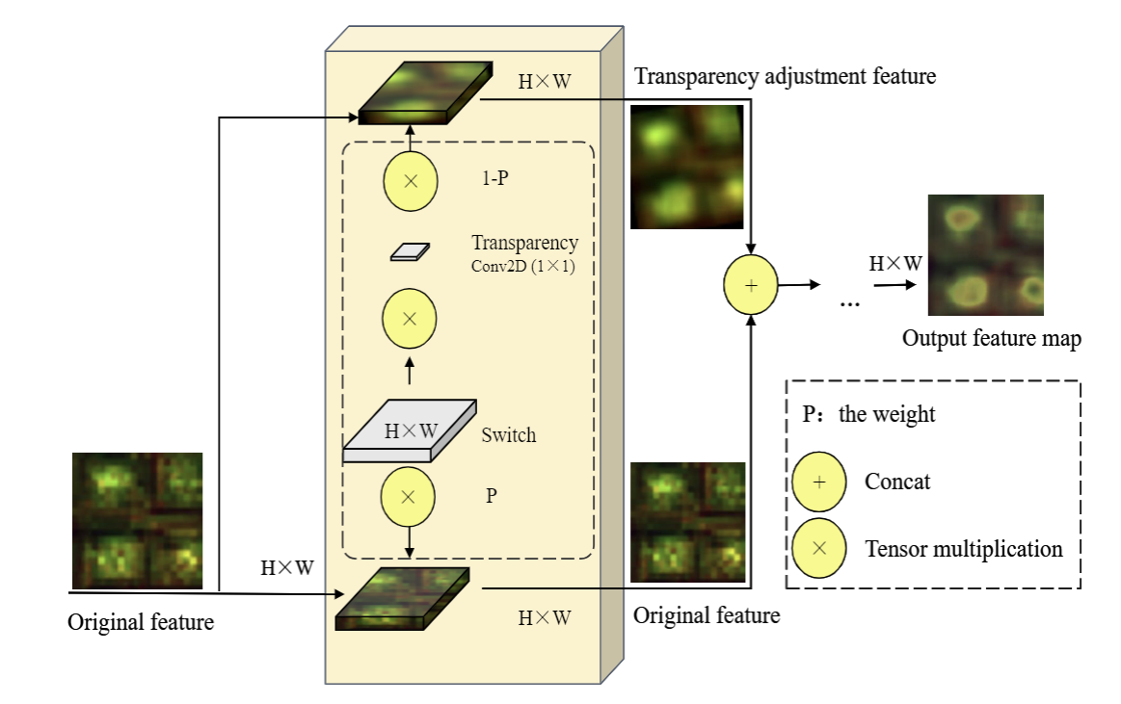
The above figure observes the key points in it:
1. Dynamic Robust Switching (DRS) is an adaptive decision switch in the environment. The mechanism works by monitoring the local mean of the feature map in real time, using a two-channel adjustable transparency fusion strategy, which is capable of observing the input features twice, which means that the same set of input features, which are sensed by the fuzzy recognition convolutional unit, are incorporated into the output of the transparency switching mechanism, which enhances the ability to capture the fuzzy features in the input features.
2. Application of the switch: the switch determines the ability of the model to perceive the degree of fuzzy features, the switching ability depends on the feature itself and the spatial scale.
Summary: The DRS unit This “dual observation fusion strategy” can effectively recognize complex fuzzy scenes, and the design effectively improves the flexibility of the model's feature extraction.

The following are some of the detection results.

code reproduction
class Fuzzy_Conv(nn.Conv2d):
"""A module that shifts the input tensor left by n pixels and then adds it to the original input."""
def __init__(self,
in_channels,
out_channels,
kernel_size,
s=1,
p=None,
g=1,
d=1,
act=True,
bias=True,
n_pixels=40):
"""
Args:
n_pixels (int): Number of pixels to pan left, default is 1
"""
super().__init__(
in_channels,
out_channels,
kernel_size,
stride=s,
padding=p,
groups=g,
bias=bias)
self.n_pixels = n_pixels
self.pre_context = torch.nn.Conv2d(
self.in_channels,
self.in_channels,
kernel_size=1,
bias=True)
self.pre_context.weight.data.fill_(0)
self.pre_context.bias.data.fill_(0)
self.switch = torch.nn.Conv2d(
self.in_channels,
1,
kernel_size=1,
stride=s,
bias=True)
self.switch.weight.data.fill_(0)
self.switch.bias.data.fill_(1)
self.post_context = torch.nn.Conv2d(
self.out_channels,
self.out_channels,
kernel_size=1,
bias=True)
self.post_context.weight.data.fill_(0)
self.post_context.bias.data.fill_(0)
self.bn = nn.BatchNorm2d(out_channels)
self.act = Conv.default_act if act is True else act if isinstance(act, nn.Module) else nn.Identity()
def forward(self, x):
global num
# pre-context
avg_x = torch.nn.functional.adaptive_avg_pool2d(x, output_size=1)
avg_x = self.pre_context(avg_x)
avg_x = avg_x.expand_as(x)
x = x + avg_x
# Visualize and save
saved_path = visualize_4d_tensor(x,num,'./vis_results(1)'
# switch
avg_x = torch.nn.functional.pad(x, pad=(2, 2, 2, 2), mode="reflect")
avg_x = torch.nn.functional.avg_pool2d(avg_x, kernel_size=5, stride=1, padding=0)
switch = self.switch(avg_x)
#Rotation
output_tensor = rotate_4d_tensor(avg_x, angle_degrees=10)
saved_path = visualize_4d_tensor(output_tensor,num,'./vis_results(2)')
#put together
out = switch * avg_x + (1 - switch) * output_tensor
#post-processing
avg_x = torch.nn.functional.adaptive_avg_pool2d(out, output_size=1)
avg_x = self.post_context(avg_x)
avg_x = avg_x.expand_as(out)
out = out + avg_x
out= self.act(self.bn(out))
return out

def rotate_4d_tensor(tensor, angle_degrees=45):
"""
Rotates a 4-dimensional tensor (N, C, H, W) by a specified angle (default 45 degrees)
Parameters:
tensor: input tensor, shape e.g. (1, 256, 20, 20)
angle_degrees: angle of rotation (positive clockwise)
Returns:
rotated tensor (shape unchanged, boundaries may be padded with 0)
"""
if tensor.dim() != 4:
raise ValueError("The input must be a four-dimensional tensor (N, C, H, W)")
N, C, H, W = tensor.shape
angle_rad = math.radians(angle_degrees)
# Construct a rotation matrix (2x3) with the same data type as the input tensor
rotation_matrix = torch.tensor([
[math.cos(angle_rad), -math.sin(angle_rad), 0],
[math.sin(angle_rad), math.cos(angle_rad), 0]
], dtype=tensor.dtype, device=tensor.device) # 自动匹配dtype
# Extend rotation matrix to batch size (N, 2, 3)
rotation_matrix = rotation_matrix.unsqueeze(0).repeat(N, 1, 1)
# Generate sampling grids (data types are automatically inherited)
grid = F.affine_grid(rotation_matrix, tensor.size(), align_corners=False)
# Perform rotations (automatic handling of data types)
rotated_tensor = F.grid_sample(
tensor,
grid,
align_corners=False,
mode='bilinear',
padding_mode='zeros'
)
return rotated_tensor
Steps to add DFRC:
1. Create the file
Step 1. In YOLOv11 official code ultralytics/nn/, create a new directory Addmodules, create a new py file in it and copy the code in.
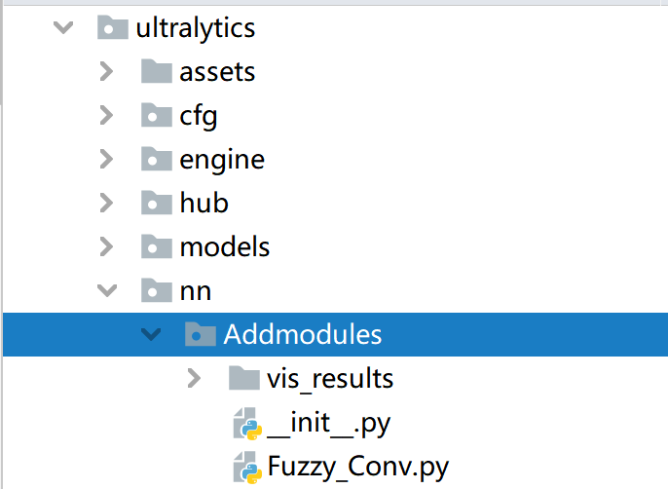
Step 2: Create a new __init__.py file in the modified directory and import from .Fuzzy_Conv import*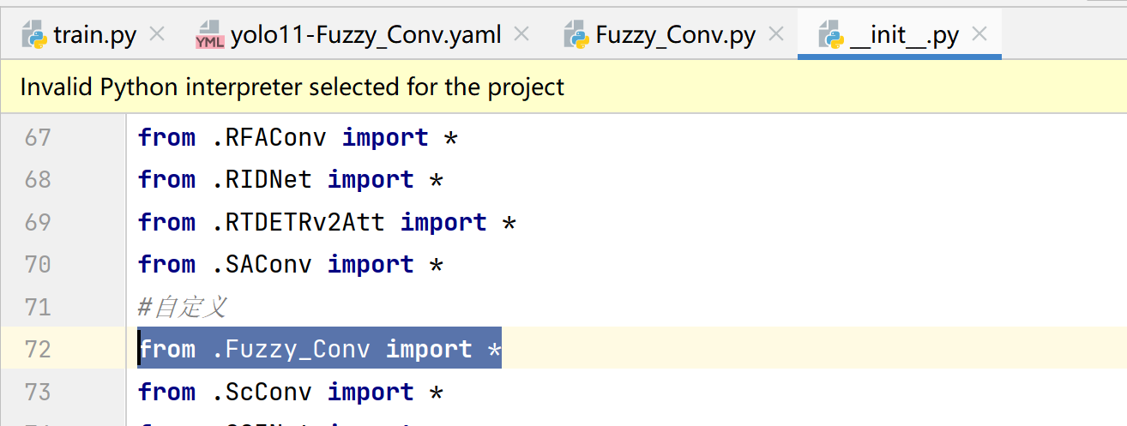
Step 3: Import and register our module in the following file: ultralytics/nn/tasks.py.
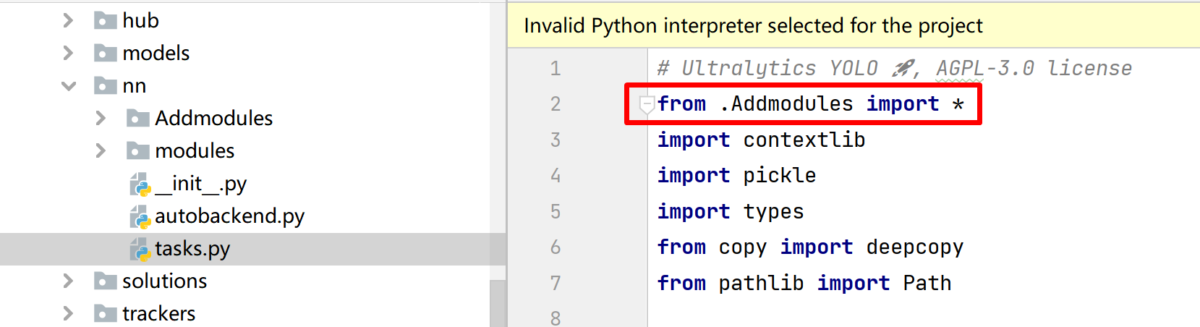

Step 4: Add the module in parse_model.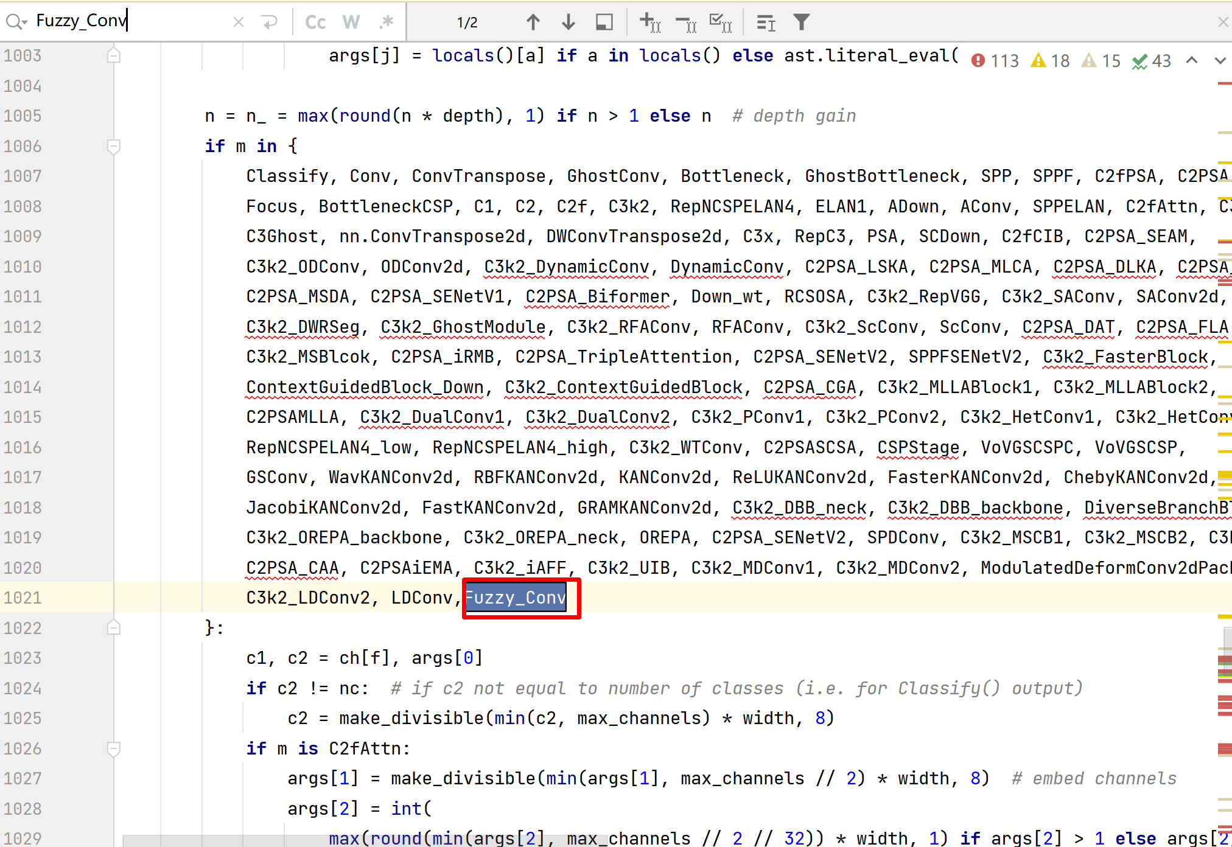
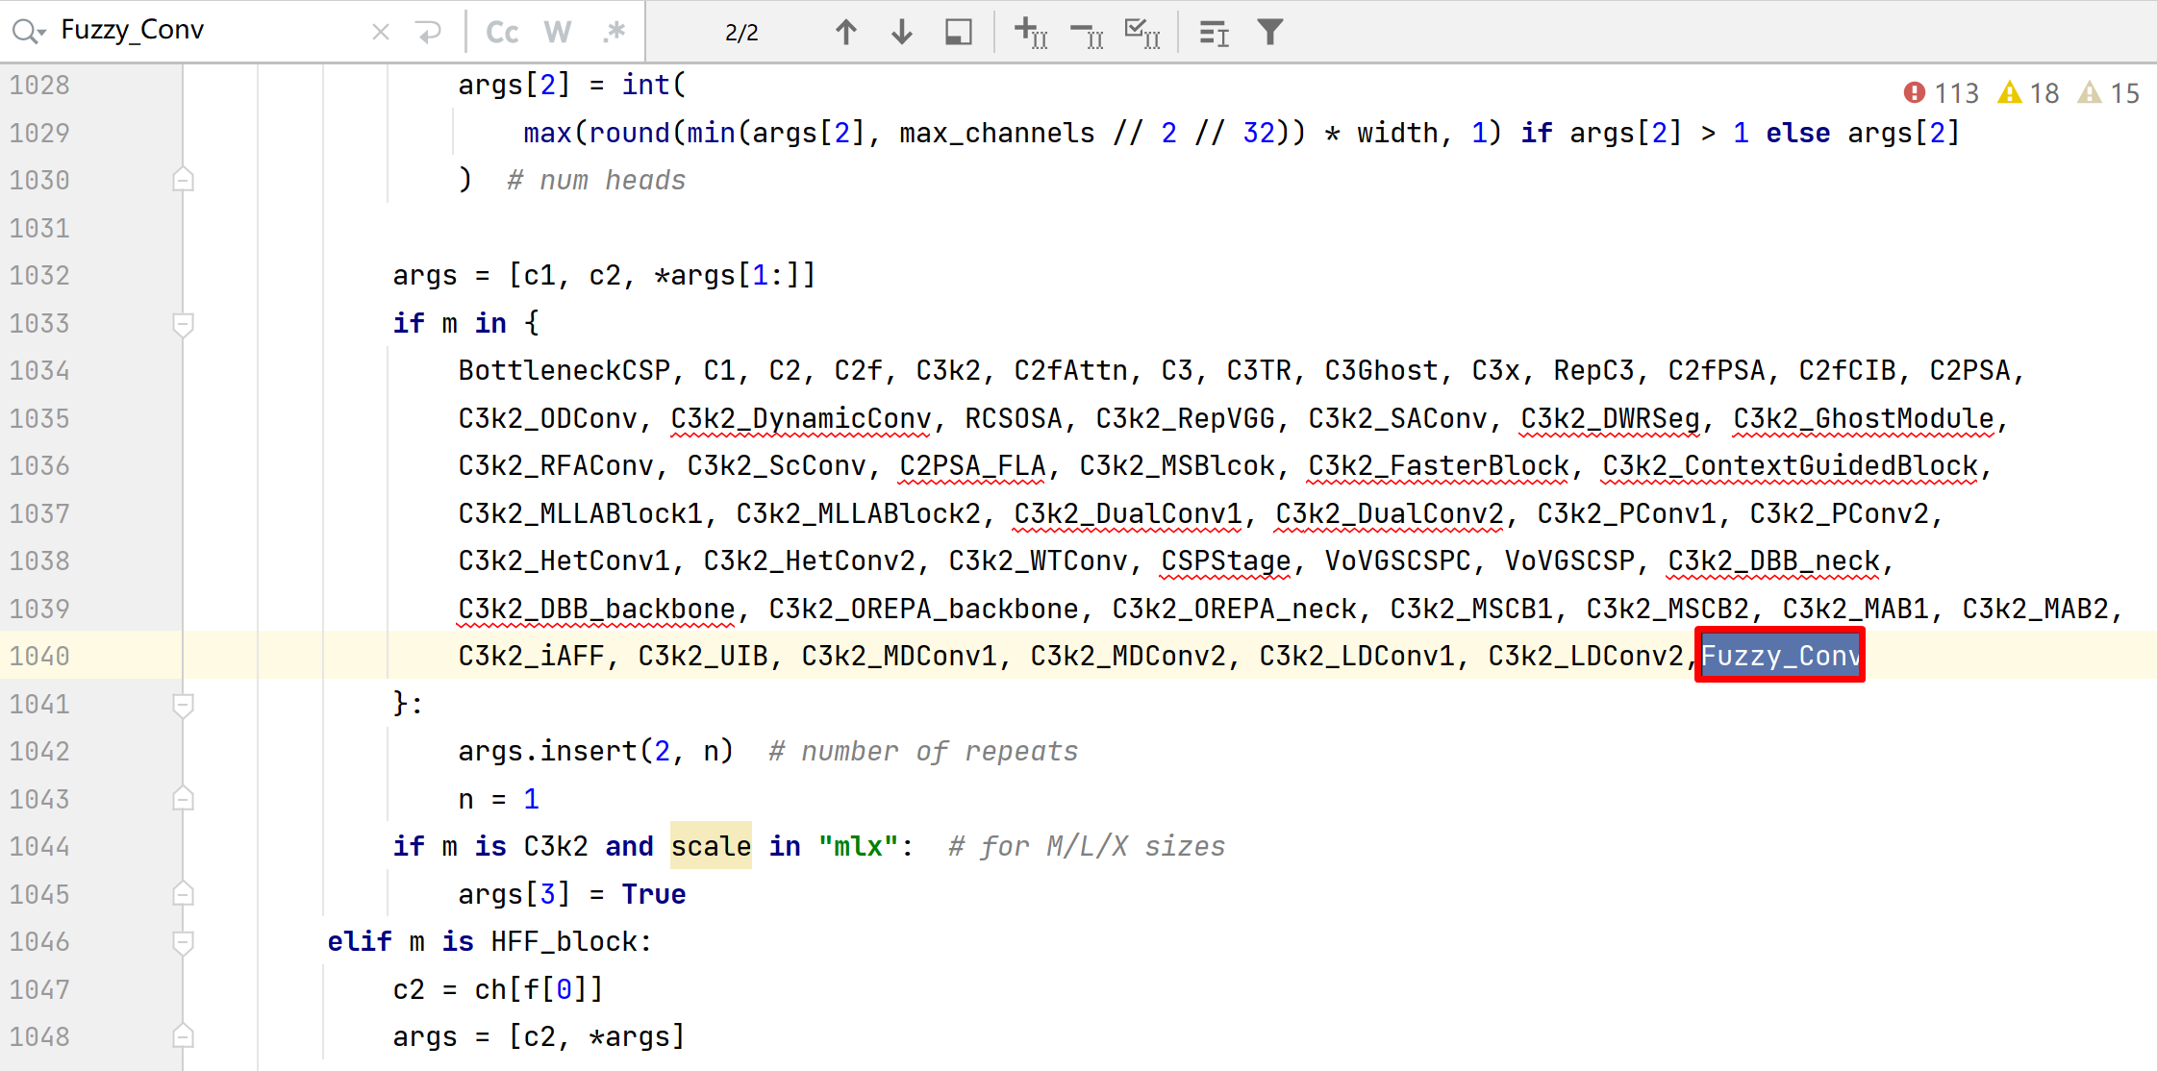
Step 5: Designing the network structure# YOLO11n backbone
backbone:
# [from, repeats, module, args]
- [-1, 1, Conv, [64, 3, 2]] # 0-P1/2
- [-1, 1, Conv, [128, 3, 2]] # 1-P2/4
- [-1, 2, C3k2, [256, False, 0.25]]
- [-1, 1, Conv, [256, 3, 2]] # 3-P3/8
- [-1, 2, C3k2, [512, False, 0.25]]
- [-1, 1, Conv, [512, 3, 2]] # 5-P4/16
- [-1, 2, C3k2, [512, True]]
- [-1, 1, Conv, [1024, 3, 2]] # 7-P5/32
- [-1, 2, C3k2, [1024, True]]
- [-1, 1, SPPF, [1024, 5]] # 9
- [-1, 2, C2PSA, [1024]] # 10
- [-1, 2, Fuzzy_Conv, [1024,256,1,1]] # 10-1
# YOLO11n head
head:
- [-2, 1, nn.Upsample, [None, 2, "nearest"]]
- [[-1, 6], 1, Concat, [1]] # cat backbone P4
- [-2, 2, C3k2, [512, False]] # 13
- [-1, 2, Fuzzy_Conv, [512,512,1,1]] # 13-1
- [-2, 1, nn.Upsample, [None, 2, "nearest"]]
- [[-1, 4], 1, Concat, [1]] # cat backbone P3
- [-1, 2, C3k2, [256, False]] # 16 (P3/8-small)
- [-1, 1, Conv, [256, 3, 2]]
- [[-1, 14], 1, Concat, [1]] # cat head P4
- [-1, 2, C3k2, [512, False]] # 19 (P4/16-medium)
- [-1, 1, Conv, [512, 3, 2]]
- [[-1, 11], 1, Concat, [1]] # cat head P5
- [-1, 2, C3k2, [1024, True]] # 22 (P5/32-large)
- [[16, 19, 22], 1, Detect, [nc]] # Detect(P3, P4, P5)
Step 6: Training code
path: /root/autodl-tmp/nzh-snu-YOLOv11/ultralytics/data8/datasets
train: # train images (relative to 'path') 16551 images
# - train.txt
- ./images/train
val: # val images (relative to 'path') 4952 images
# - val.txt
- ./images/val
test: # test images (optional)
# - test.txt
- ./images/test
nc: 8
# Classes ['Bacterial_Leaf_Blight', 'Brown_Spot', 'HealthyLeaf', 'Leaf_Blast', 'Leaf_Scald', 'Narrow_Brown_Leaf_Spot', 'Neck_Blast', 'Rice_Hispa']
names:
0: Bacterial_Leaf_Blight
1: Brown_Spot
2: HealthyLeaf
3: Leaf_Blast
4: Leaf_Scald
5: Narrow_Brown_Leaf_Spot
6: Neck_Blast
7: Rice_Hispa

import warnings
warnings.filterwarnings('ignore')
from ultralytics import YOLO
if __name__ == '__main__':
model = YOLO(r'./ultralytics/cfg/models/11/yolo11-Fuzzy_Conv.yaml')
model.train(data=r"./ultralytics/data8/data.yaml",
task='detect',
cache=False,
imgsz=640,
epochs=500,
single_cls=False,
batch=32,
close_mosaic=0,
workers=5,
device='0',
optimizer='SGD',
amp=True,
project='runs/train',
name='exp',
)
eigenmap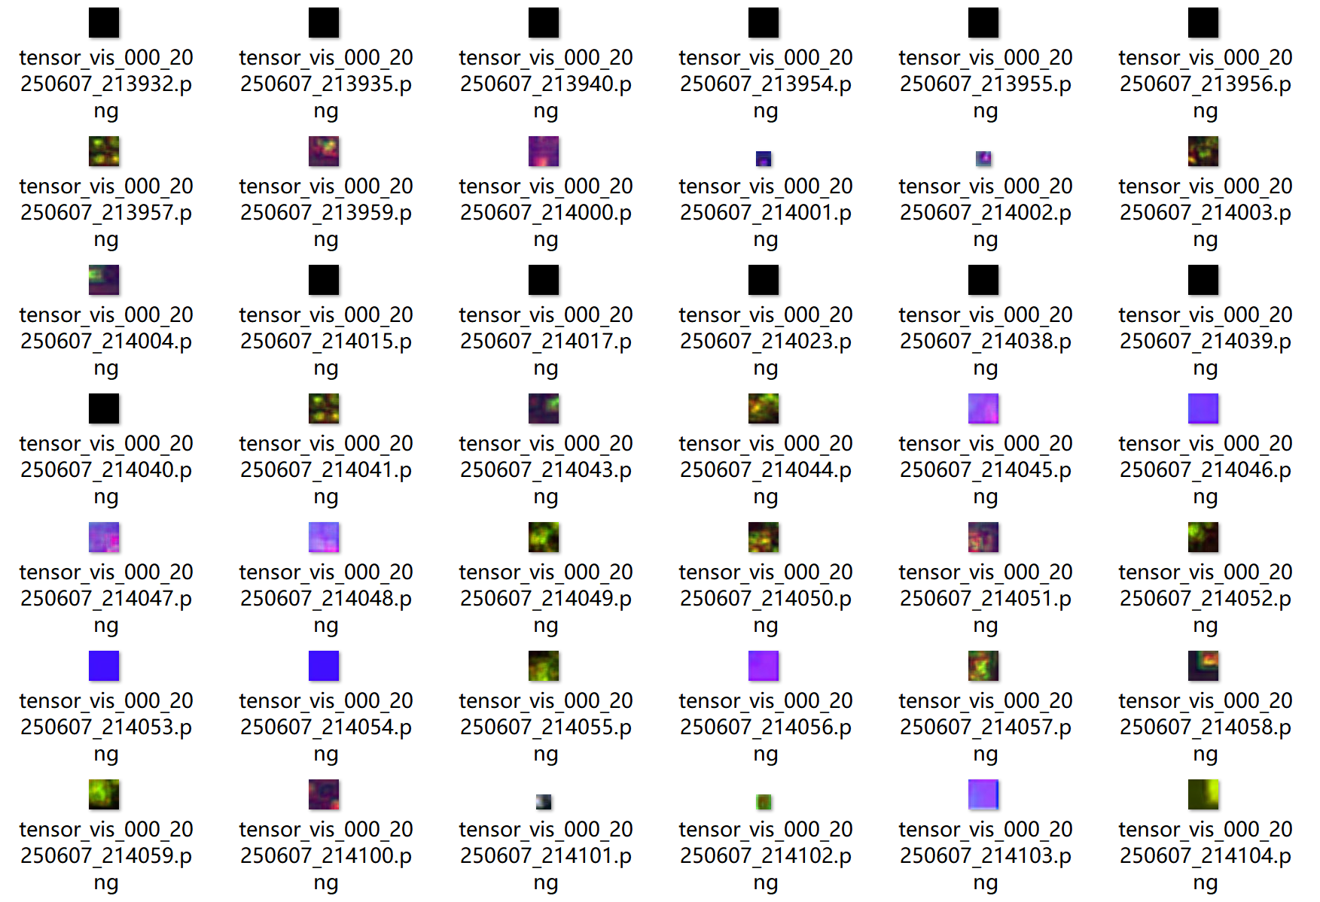
Heat map of fuzzy images
Original image | YOLOv11 | YOLOv11-DFRC
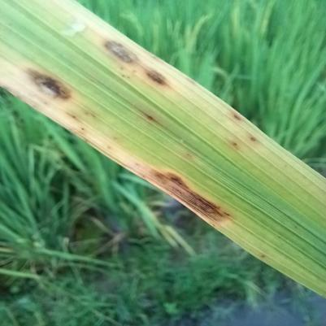 | 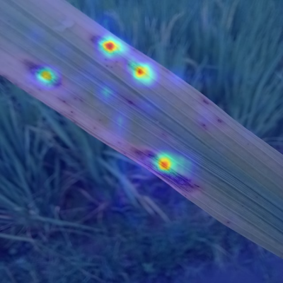 | 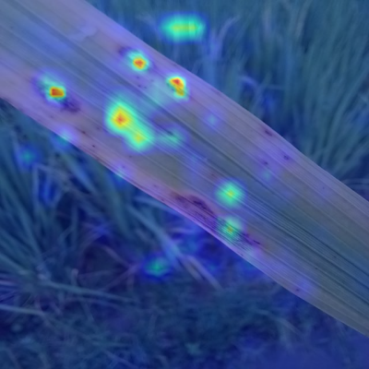
blurred scene | YOLOv11 | YOLOv11-DFRC
 | 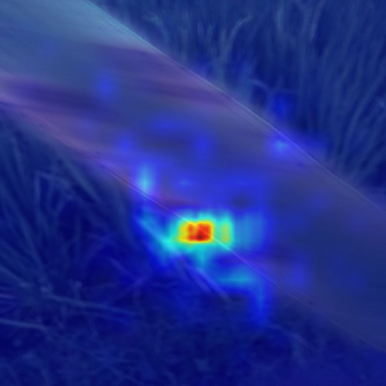 | 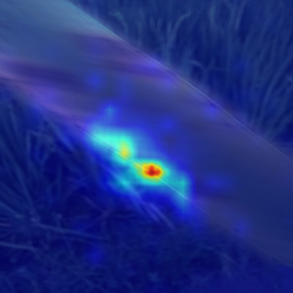
cloudy day | YOLOv11 | YOLOv11-DFRC
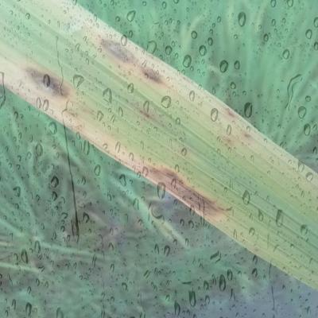 | 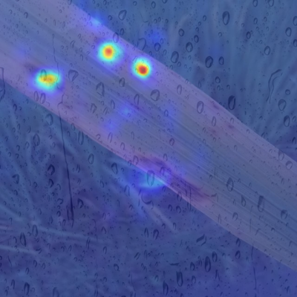 | 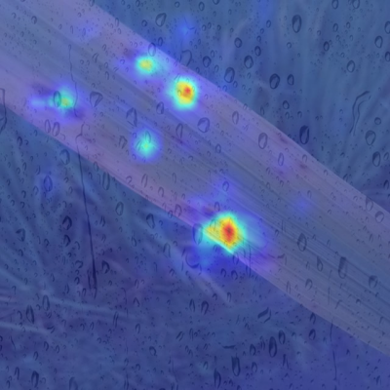
Dataset link:
Link: https://pan.quark.cn/s/d9744d62a279
Extraction code: p17y

